**Assignment No. 5**

**Aim:** Usepacket tracer tool for configuration of 3 router network using one of the following protocol RIP/ OSPF/ BGP.

**Theory:**

1. **What is Static routing? Write advantages and disadvantages of it**

**Ans:** Static routing is a type of network routing where routes are manually configured and set by the network administrator instead of being dynamically updated by routing protocols. It involves specifying a fixed path for network traffic to reach its destination.

In static routing, administrators manually add routes to the routing table using commands such as:

**ip route <destination_network> <subnet_mask> <next_hop_address>**

**Advantages of Static Routing**

1. **Simplicity** – Easy to configure and maintain for small networks.
2. **Less Overhead** – No extra CPU or memory usage since no dynamic route calculations are needed.
3. **More Secure** – Since routes are manually defined, there is no risk of routing table manipulation by malicious attacks.
4. **Predictability** – The network administrator has full control over how traffic flows.
5. **No Bandwidth Consumption** – Unlike dynamic routing, it does not send periodic updates, saving bandwidth.

**Disadvantages of Static Routing**

1. **Not Scalable** – Becomes difficult to manage in large networks due to manual configuration.
2. **No Automatic Failover** – If a link fails, manual intervention is required to update the routes.
3. **Time-Consuming** – Configuration and maintenance require more effort, especially for complex networks.
4. **Prone to Human Errors** – A single incorrect route can cause connectivity issues.
5. **Difficult to Adapt to Network Changes** – Any changes in topology require manual updates to routing tables.
6. **What is Dynamic Routing? Write advantages and disadvantages of it.**

**Ans:** Dynamic routing is a network routing technique where routers automatically learn and update routes using routing protocols. Unlike static routing, which requires manual configuration, dynamic routing adapts to changes in the network topology by exchanging routing information with other routers.

Common dynamic routing protocols:

* **RIP (Routing Information Protocol)** – Distance-vector protocol, updates every 30 seconds.
* **OSPF (Open Shortest Path First)** – Link-state protocol, calculates the shortest path using Dijkstra’s algorithm.

**Dynamic Routing Commands**

**1. Configuring RIP (Routing Information Protocol) in Cisco Routers**

Router(config)# router rip

Router(config-router)# version 2

Router(config-router)# network 192.168.1.0

Router(config-router)# exit

Router(config)# end

Router# write memory

* Enables RIP version 2.
* Advertises the 192.168.1.0 network.
* Saves the configuration.

**2. Configuring OSPF (Open Shortest Path First) in Cisco Routers**

Router(config)# router ospf 1

Router(config-router)# network 192.168.1.0 0.0.0.255 area 0

Router(config-router)# exit

Router(config)# end

Router# write memory

* Enables OSPF process ID 1.
* Adds network 192.168.1.0/24 to OSPF area 0.
* Saves the configuration.

**Advantages of Dynamic Routing**

1. **Automatic Route Updates** – Adjusts routes dynamically when the network changes.
2. **Scalability** – Efficiently handles large networks.
3. **Redundancy & Failover** – Automatically finds alternative routes in case of failure.
4. **Efficient Network Utilization** – Optimizes traffic flow and reduces congestion.
5. **Less Manual Work** – No need for frequent manual configuration.

**Disadvantages of Dynamic Routing**

1. **Higher Resource Consumption** – Uses CPU, memory, and bandwidth for route calculations.
2. **Complex Setup** – Requires knowledge of routing protocols.
3. **Slower Convergence** – Takes time for routers to update their tables during topology changes.
4. **Security Risks** – Vulnerable to attacks like route hijacking and spoofing.
5. **Unnecessary for Small Networks** – Adds complexity without significant benefits.
6. **List and explain different dynamic routing protocols along with their features, working advantages, limitations and applications.(RIP, OSPF and BGP)**

**Ans:** Dynamic routing protocols help routers automatically exchange routing information and update routing tables in real time. The three commonly used dynamic routing protocols are **RIP (Routing Information Protocol), OSPF (Open Shortest Path First), and BGP (Border Gateway Protocol).**

**1. Routing Information Protocol (RIP)**

**Features**

* Distance-vector protocol that uses hop count as the metric.
* Maximum hop count of 15 to prevent routing loops.
* Periodic updates sent every 30 seconds.
* Supports RIPv1 (Classful) and RIPv2 (Classless, supports subnetting and authentication).

**Working**

* Each router maintains a routing table with destination networks and the number of hops.
* Routers exchange routing tables every 30 seconds.
* If a new route is learned, it is added to the table with the hop count incremented.
* If a route is unreachable, the router marks it as invalid and removes it after a hold-down timer expires.

**Advantages**

* Easy to configure and suitable for small networks.
* Uses split horizon and route poisoning to prevent routing loops.
* Standardized and supported on most networking devices.

**Limitations**

* Slow convergence, making it inefficient in large networks.
* Limited scalability as it supports a maximum of 15 hops.
* High bandwidth usage due to frequent updates.

**Applications**

* Small office and home networks.
* Simple networks with minimal topology changes.

**2. Open Shortest Path First (OSPF)**

**Features**

* Link-state protocol that calculates the shortest path using Dijkstra’s Algorithm.
* Supports hierarchical routing with areas (Area 0 is the backbone).
* Uses cost as a metric, calculated based on bandwidth.
* Faster convergence compared to RIP.
* Supports VLSM (Variable Length Subnet Masking) and authentication.

**Working**

* Each router maintains a link-state database (LSDB) of the entire network.
* Routers send LSAs (Link State Advertisements) to update their LSDBs.
* Dijkstra’s algorithm computes the shortest path tree for each router.
* Only changes are propagated instead of entire routing tables.

**Advantages**

* Fast convergence allows quick adaptation to topology changes.
* Scalable and suitable for large enterprise networks.
* Efficient bandwidth usage as updates are only sent when changes occur.
* Supports multi-area routing for better network organization.

**Limitations**

* Complex configuration that requires detailed planning.
* High memory and CPU usage due to large routing tables.
* Troubleshooting OSPF issues can be challenging.

**Applications**

* Large enterprise networks.
* ISPs and service provider networks.
* Multi-layered network architectures.

**3. Border Gateway Protocol (BGP)**

**Features**

* Path-vector protocol used for inter-domain routing.
* Uses AS (Autonomous System) numbers to route between ISPs.
* Selects the best path based on attributes like AS path, next-hop, MED, and local preference.
* BGP-4 supports CIDR (Classless Inter-Domain Routing) to optimize IP address usage.
* Works with eBGP (External BGP, between AS) and iBGP (Internal BGP, within AS).

**Working**

* Each BGP router maintains a routing table of AS paths rather than individual network hops.
* Peering routers exchange updates only when a route changes.
* The best route is selected based on multiple attributes.
* BGP routers use TCP (port 179) for reliable communication.

**Advantages**

* Highly scalable and used in global internet routing.
* Selects the best path based on multiple attributes.
* Stable and reliable, as updates are only sent when changes occur.
* Supports load balancing by distributing traffic across multiple links.

**Limitations**

* Complex configuration requiring expertise and careful tuning.
* Slow convergence, making it less responsive to topology changes.
* Vulnerable to security threats like route hijacking attacks.

**Applications**

* Internet backbone routing (ISPs, data centers).
* Large-scale cloud networks (Google, AWS, Azure).
* Multi-homed enterprises using multiple ISPs.

1. **Difference between RIP and OSPF**

### **Ans:**

|  |  |  |
| --- | --- | --- |
| Feature | RIP (Routing Information Protocol) | OSPF (Open Shortest Path First) |
| Type | Distance-vector routing protocol | Link-state routing protocol |
| Metric Used | Hop count | Cost (based on bandwidth) |
| Hop Limit | Maximum 15 hops (limits scalability) | No hop limit (scalable for large networks) |
| Algorithm | Bellman-Ford Algorithm | Dijkstra’s Algorithm |
| Convergence Time | Slow convergence (due to periodic updates) | Fast convergence (only updates changes) |
| Routing Updates | Sends entire routing table every 30 seconds | Sends only changes through LSAs |
| Network Overhead | High bandwidth usage due to frequent updates | Low bandwidth usage as updates are sent only when needed |
| Scalability | Suitable for small networks | Suitable for large enterprise networks |
| Classful/Classless | RIPv1 is classful, RIPv2 is classless | Supports classless routing |
| VLSM and CIDR Support | Only RIPv2 supports VLSM and CIDR | Fully supports VLSM and CIDR |
| Loop Prevention | Uses split horizon, route poisoning | Uses SPF calculations to avoid loops |
| Load Balancing | Supports equal-cost load balancing | Supports both equal and unequal-cost load balancing |
| Administrative Distance | 120 | 110 |
| Security | Limited security, no authentication in RIPv1 | Supports authentication for better security |
| Complexity | Easy to configure and manage | Complex configuration and requires more resources |
| Application | Small office and home networks | Large-scale enterprise and ISP networks |

1. **Configuration of RIP (include screenshots)**

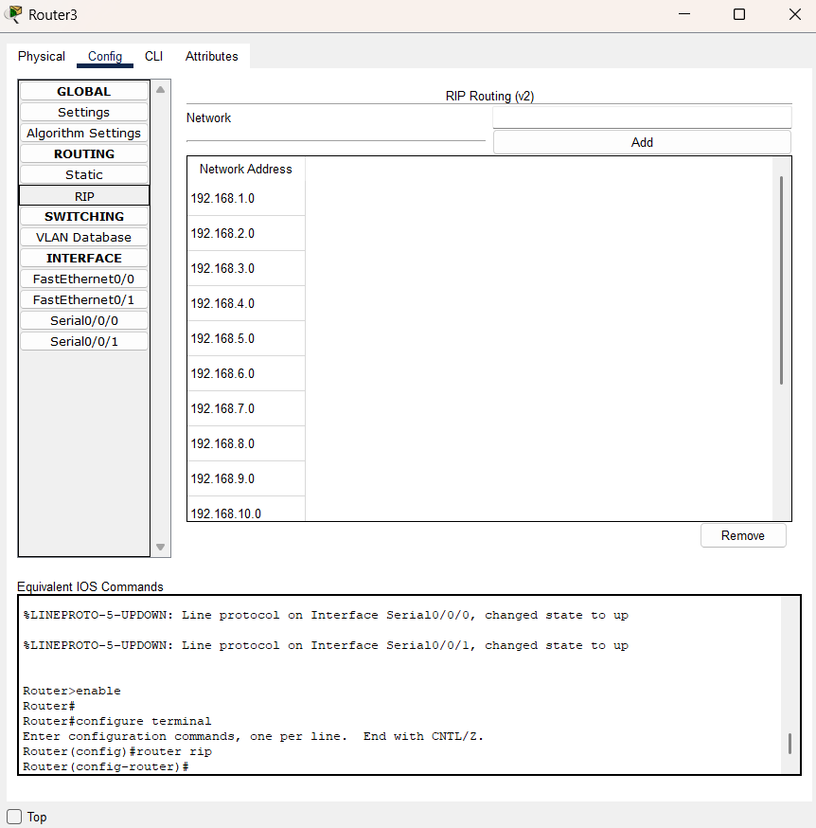

**Explanation of the RIP Configuration**

1. **Routing Protocol: RIP Version 2**
   * The router is configured with **Routing Information Protocol (RIP) v2**, which supports classless routing and subnetting.
2. **Network Configuration**
   * Multiple **network addresses** (192.168.1.0 to 192.168.14.0) are added under RIP, allowing the router to share these networks with neighboring routers.
   * These addresses belong to different subnets, ensuring communication between different network segments.
3. **Routing Update Mechanism**
   * RIP works by **broadcasting routing updates** at regular intervals (every 30 seconds).
   * It uses a **hop count metric**, with a maximum limit of **15 hops**, meaning any route beyond 15 hops is considered unreachable.
4. **Configuration Process (CLI Commands)**
   * enable → Enters privileged EXEC mode.
   * configure terminal → Enters global configuration mode.
   * router rip → Enables the RIP routing protocol.
   * Networks are added under the RIP process to allow dynamic route propagation.

**Commands For Configuration:**

Router> enable

Router# configure terminal

Router(config)# router rip

Router(config-router)# version 2

Router(config-router)# network 192.168.1.0

Router(config-router)# network 192.168.2.0

Router(config-router)# network 192.168.3.0

Router(config-router)# network 192.168.4.0

Router(config-router)# network 192.168.5.0

Router(config-router)# network 192.168.6.0

Router(config-router)# network 192.168.7.0

Router(config-router)# network 192.168.8.0

Router(config-router)# network 192.168.9.0

Router(config-router)# network 192.168.10.0

Router(config-router)# network 192.168.11.0

Router(config-router)# network 192.168.12.0

Router(config-router)# network 192.168.13.0

Router(config-router)# network 192.168.14.0

Router(config-router)# no auto-summary

Router(config-router)# end

Router# write memory

1. **Configuration of OSPF (include screenshots and commands)**

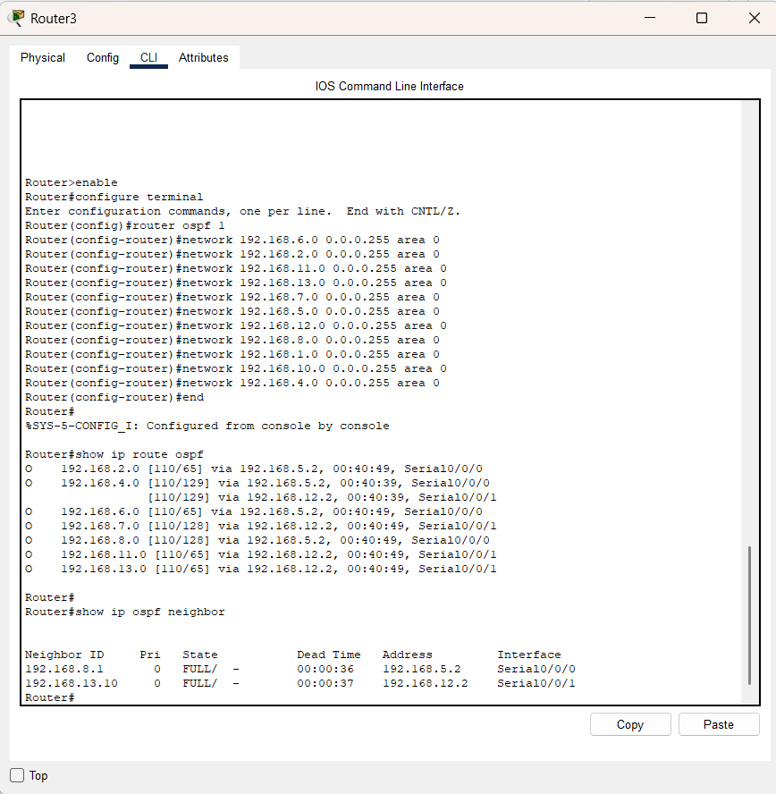

The screenshot shows the configuration of **OSPF (Open Shortest Path First) Protocol** on **Router3** using **Cisco Packet Tracer**.

* In the **CLI (Command Line Interface)**, the user has enabled OSPF by entering **router ospf 1** under global configuration mode.
* Multiple **network statements** are used to advertise IP subnets (**192.168.2.0 to 192.168.13.0**) in **Area 0**, allowing the router to exchange routing information dynamically.
* The **show ip route ospf** command displays OSPF-learned routes, showing:
  + The **OSPF administrative distance (110)** and cost (metric).
  + **Next-hop IP addresses** and the **interface (Serial0/0/0 or Serial0/0/1)** used to reach each network.
  + **Timers** indicating how long each route has been in the table.

This setup ensures that Router3 learns and shares routing information efficiently, allowing for **dynamic path selection and route updates** in a multi-router network.

**Commands for configuration:**

Router> enable

Router# configure terminal

Router(config)# router ospf 1

Router(config-router)# network 192.168.6.0 0.0.0.255 area 0

Router(config-router)# network 192.168.2.0 0.0.0.255 area 0

Router(config-router)# network 192.168.11.0 0.0.0.255 area 0

Router(config-router)# network 192.168.13.0 0.0.0.255 area 0

Router(config-router)# network 192.168.7.0 0.0.0.255 area 0

Router(config-router)# network 192.168.5.0 0.0.0.255 area 0

Router(config-router)# network 192.168.8.0 0.0.0.255 area 0

Router(config-router)# network 192.168.10.0 0.0.0.255 area 0

Router(config-router)# network 192.168.4.0 0.0.0.255 area 0

Router(config-router)# end

Router# show ip route ospf

Router# show ip ospf neighbor

1. **Output (include screenshots and addressing table):**

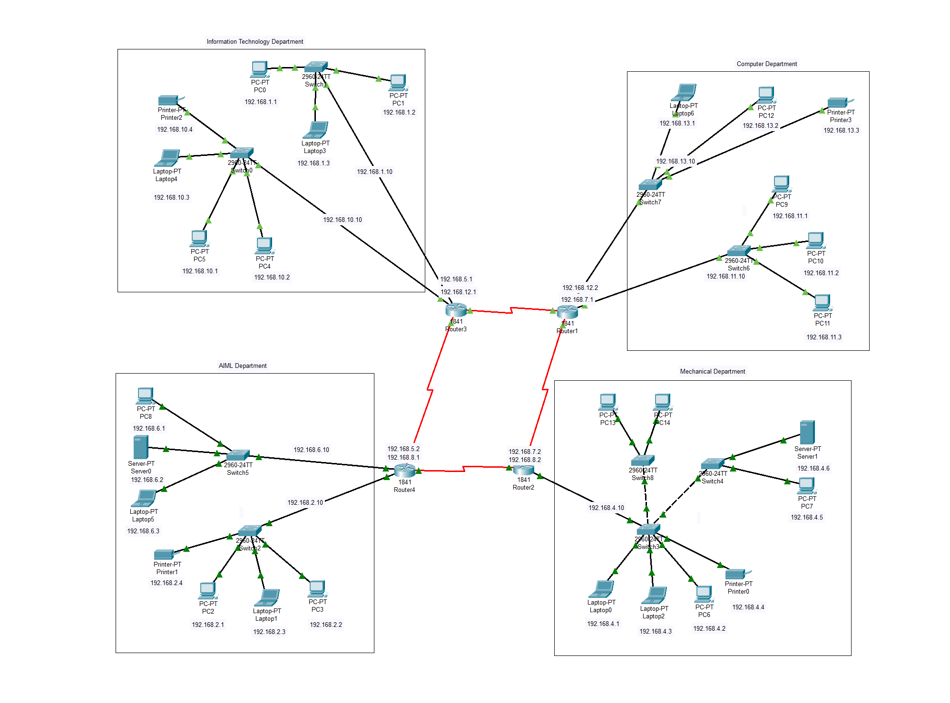

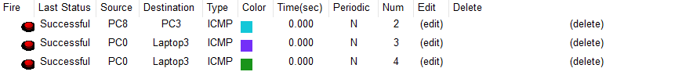

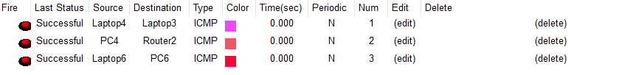

**Addressing tables:**

**1. Information Technology (IT) Department**

|  |  |  |  |  |  |
| --- | --- | --- | --- | --- | --- |
| Device Name | Device Type | IP Address | Subnet Mask | Default Gateway | Interface |
| PC0 | PC | 192.168.1.1 | 255.255.255.0 | 192.168.1.10 | FastEthernet0/0 |
| PC1 | PC | 192.168.1.2 | 255.255.255.0 | 192.168.1.10 | FastEthernet0/0 |
| Laptop3 | Laptop | 192.168.1.3 | 255.255.255.0 | 192.168.1.10 | FastEthernet0/0 |
| PC4 | PC | 192.168.10.2 | 255.255.255.0 | 192.168.10.10 | FastEthernet0/0 |
| PC5 | PC | 192.168.10.1 | 255.255.255.0 | 192.168.10.10 | FastEthernet0/0 |
| Laptop4 | Laptop | 192.168.10.3 | 255.255.255.0 | 192.168.10.10 | FastEthernet0/0 |
| Printer2 | Printer | 192.168.10.4 | 255.255.255.0 | 192.168.10.10 | FastEthernet0/0 |

**2. Computer Department**

|  |  |  |  |  |  |
| --- | --- | --- | --- | --- | --- |
| Device Name | Device Type | IP Address | Subnet Mask | Default Gateway | Interface |
| Laptop6 | Laptop | 192.168.13.1 | 255.255.255.0 | 192.168.13.10 | FastEthernet0/0 |
| PC12 | PC | 192.168.13.2 | 255.255.255.0 | 192.168.13.10 | FastEthernet0/0 |
| Printer3 | Printer | 192.168.13.3 | 255.255.255.0 | 192.168.13.10 | FastEthernet0/0 |
| PC9 | PC | 192.168.11.1 | 255.255.255.0 | 192.168.11.10 | FastEthernet0/0 |
| PC10 | PC | 192.168.11.2 | 255.255.255.0 | 192.168.11.10 | FastEthernet0/0 |
| PC11 | PC | 192.168.11.3 | 255.255.255.0 | 192.168.11.10 | FastEthernet0/0 |

**3. AIML Department**

|  |  |  |  |  |  |
| --- | --- | --- | --- | --- | --- |
| Device Name | Device Type | IP Address | Subnet Mask | Default Gateway | Interface |
| PC8 | PC | 192.168.6.1 | 255.255.255.0 | 192.168.6.10 | FastEthernet0/0 |
| Server0 | Server | 192.168.6.2 | 255.255.255.0 | 192.168.6.10 | FastEthernet0/0 |
| Laptop5 | Laptop | 192.168.6.3 | 255.255.255.0 | 192.168.6.10 | FastEthernet0/0 |
| Printer1 | Printer | 192.168.2.4 | 255.255.255.0 | 192.168.2.10 | FastEthernet0/0 |
| PC2 | PC | 192.168.2.1 | 255.255.255.0 | 192.168.2.10 | FastEthernet0/0 |
| PC3 | PC | 192.168.2.2 | 255.255.255.0 | 192.168.2.10 | FastEthernet0/0 |
| Laptop1 | Laptop | 192.168.2.3 | 255.255.255.0 | 192.168.2.10 | FastEthernet0/0 |

**4.Mechanical Department**

|  |  |  |  |  |  |
| --- | --- | --- | --- | --- | --- |
| Device Name | Device Type | IP Address | Subnet Mask | Default Gateway | Interface |
| PC13 | PC | 192.168.4.1 | 255.255.255.0 | 192.168.4.10 | FastEthernet0/0 |
| PC14 | PC | 192.168.4.2 | 255.255.255.0 | 192.168.4.10 | FastEthernet0/0 |
| Laptop0 | Laptop | 192.168.4.3 | 255.255.255.0 | 192.168.4.10 | FastEthernet0/0 |
| Laptop2 | Laptop | 192.168.4.4 | 255.255.255.0 | 192.168.4.10 | FastEthernet0/0 |
| PC6 | PC | 192.168.4.2 | 255.255.255.0 | 192.168.4.10 | FastEthernet0/0 |
| PC7 | PC | 192.168.4.5 | 255.255.255.0 | 192.168.4.10 | FastEthernet0/0 |
| Server1 | Server | 192.168.4.6 | 255.255.255.0 | 192.168.4.10 | FastEthernet0/0 |
| Printer0 | Printer | 192.168.4.4 | 255.255.255.0 | 192.168.4.10 | FastEthernet0/0 |

1. **Conclusion:**

In this assignment, we explored the configuration of a three-router network using the Packet Tracer tool and implemented dynamic routing protocols, specifically RIP and OSPF. We compared static and dynamic routing, understanding their advantages, limitations, and real-world applications.

By configuring RIP and OSPF, we observed how these protocols enable efficient network communication by dynamically updating routing tables and finding optimal paths. RIP, being a distance-vector protocol, is simpler but less scalable, whereas OSPF, a link-state protocol, offers better efficiency and scalability for large networks.

Through practical implementation, we gained hands-on experience in configuring routing protocols, understanding their working principles, and troubleshooting network connectivity issues. This assignment reinforced the importance of dynamic routing in modern network infrastructure, preparing us for more advanced networking concepts and real-world applications.